A

**PROJECT REPORT**

ON

**TRAVEL AGENCY**

Submitted to:

**KURUKSHETRA UNIVERSITY, KURUKSHETRA**

**In the partial fulfillment of the requirement for**

**B. VOC (SOFTWARE DEVELOPMENT)** SEM**-VI**

**Session 2024-2025**



**Under The Guidance Of: Submitted By:**

**Ms. Muskan Aggarwal Indrajeet Gangber**

**Assistant Professor B. VOC (SD)-III**

**Department Of Computer Science College RollNo.1221673042023**

**University No.**

**SANATAN DHARMA COLLEGE**

**AMBALA CANTT.**

ACKNOWLEDGEMENT

I take this opportunity to express my profound gratitude and deep regard to my guide **Ms.** **Muskan Aggarwal**, Department of Computer Science for her exemplary guidance, monitoring and constant encouragement throughout the course of this project. The blessing, help and guidance given by her time to time shall carry me a long way in the journey of life on which I am about to embark.

I am oblige to staff members of **SANATAN DHARMA COLLEGE, AMBALA CANTT** for the valuable information provided by them in their respective fields. I am grateful for their cooperation during the period of my assignment.

Lastly, I thank almighty, my parents and my classmates for their constant encouragement without which this assignment would not have been possible.

**Indrajeet Gangber**

**CERTIFICATE-I**

It is to validate that **Indrajeet Gangber** S/O Mr. **Kailash** of class B.Voc (software Development) 3rd year under **University Roll No. College RollNo.1221673042023** has completed the project titled “**Travel Agency**” in languages Java Script, HTML and CSS for the degree of Bachelors in Vocation (Software Development) Semester-VI under my supervision. The work done in project is a result of the candidate's own efforts and report maintains is satisfied as per requirement.

I wish him good success in his future.

Ms. Muskan Aggarwal

Project Guide

Department Of Computer Science

CERTIFICATE-II

It is to validate that **Indrajeet Gangber** S/O Mr**. Kailash** of class B. Voc (Software Development) 3rd Year under **University Roll No.**  **College Roll No. 1221673042023** has completed the project titled "**Travel Agency**" in languages , HTML and CSS for the degree of Bachelors in Vocation (Software Development)- Semester-VI under the supervision of **Ms**. **Muskan Aggarwal**. The work done in project is a result of the candidate's own efforts and report maintains is satisfied as per requirement.

We wish him good success in his future.

**Dr. Girdhar Gopal Dr. Rajinder Singh**

H. O. D. Principal

Department Of Computer Science Sanatan Dharma College,

Ambala Cantt.

**DECLARATION**

I hereby declare that this submission is my own work and that to the best of my knowledge and belief. It contains no material previously published or written by any other person nor material which to a substantial extent has been accepted for the Award of any other degree or diploma of the university or other institute or higher learning, except where acknowledgement has been made in the next.

**Indrajeet Gangber**

INDEX



1.INTRODUCTION

2.SOFTWARE AND HARDWARE REQUIREMENT

3.INTRODUCTION TO LANGUAGE

4.CODING

5.OUTPUTS

6.CONCLUSION

7.BIBILIOGRAPHY/ REFRENCES

**INTRODUCTION**

Welcome to the **Travel Agency Website Project**, a dynamic and user-friendly platform designed to inspire and facilitate unforgettable travel experiences. This project aims to provide a visually appealing and professionally structured website where users can explore destinations, learn about the agency’s services, and easily get in touch for bookings and inquiries.

The website will feature:

* A **Home Page** with an inviting overview of the agency’s offerings.
* A **Destinations Page** showcasing popular travel locations with descriptions and images.
* An **About Page** detailing the agency’s mission, values, and team.
* A **Contact Page** for inquiries, bookings, and customer support.

With a focus on modern design and seamless navigation, this project will enhance user engagement and provide an efficient digital gateway for travelers

OBJECTIVE OF THE PROJECT

The objective of the project is to design and develop a **professional and visually appealing** website for a travel agency. The website should provide an engaging user experience, showcase travel destinations, and offer essential information about the agency. The main goals include:

1. **User-Friendly Design** – Ensure intuitive navigation and an attractive layout.
2. **Responsive & Accessible** – Optimize for different devices (desktop, tablet, mobile).
3. **Engaging Content** – Present travel destinations with appealing images, descriptions, and calls to action.
4. **Informative Pages** – Include essential sections such as:
   * **Home:** Overview of the travel agency and featured destinations.
   * **Destinations:** List of popular travel locations with details.
   * **About:** Information about the agency, mission, and values.
   * **Contact:** Contact form, address, and customer service details.
5. **SEO & Performance Optimization** – Ensure fast loading times and visibility in search engines.

HARDWARE AND SOFTWARE REQUIREMENT

1.HARDWARE REQUIREMENTS-

# Intel i3 5th gen

# 8 GB Ram

# Hard Drive/SSD 256 GB

2.SOFTWARE REQUIREMENTS-

# Operating System: Windows 10

# Web – Technology: PHP

# Front-End: HTML and CSS

# Back-End: Mysql

INTRODUCTION TO LANGUAGES

INTRODUCTION TO HTML:

HTML (HyperText Markup Language) is the standard language used to create and design web pages. It provides the structure of a webpage using elements and tags.

Key Features of HTML:

Markup Language – HTML uses tags to define elements on a webpage.

Structure of Webpages – It organizes content using headings, paragraphs, images, links, tables, and more.

Hyperlinks – HTML allows linking between different webpages using anchor tags (<a>).

Forms and Input – It supports user input through forms, buttons, and text fields.

Media Support – HTML can display images, videos, and audio files.

BASIC HTML STRUCTURE:

<!DOCTYPE html>

<html>

<head>

<title>My First Webpage</title>

</head>

<body>

<h1>Welcome to HTML</h1>

<p>This is a simple introduction to HTML.</p>

</body>

</html>

-**2. INTRODUCTION TO CSS**

CSS stands for Cascading Style Sheets. CSS saves a lot of work. It can control the layout of multiple web pages all at once.

**2.1 What is CSS?**

# CSS stands for Cascading Style Sheets .

# CSS describes how HTML elements are to be displayed on screen, paper, or in other media.

# CSS saves a lot of work. It can control the layout of multiple web pages all at once.

External stylesheets are stored in CSS files.

**2.2 Why Use CSS?**

CSS is used to define styles for your web pages, including the design , layout and variations in display for different devices and screen sizes.

**CSS EXAMPLES**

body {

background-color: lightblue;

}

H1{

Color:white;

Text-align:center;

}

P {

Font-family: verdana;

Font-size: 20px;

}

2.3 CSS Solved a Big Problem

HTML was NEVER intended to contain tags for formatting a web page! HTML was created to describe the content of a web page, like:

<h1>This is a heading</h1>

<p>This is a paragraph.</p>

When tags like <font>, and color attributes were added to the HTML 3.2 specification, it started a nightmare for web developers. Development of large websites, where fonts and color information were added to every single page, became a long and expensive process.

To solve this problem, the World Wide Web Consortium (W3C) created CSS.

CSS removed the style formatting from the HTML page!

2.4 Using CSS

CSS can be added to HTML documents in 3 ways:

**Inline** - by using the style attribute inside HTML elements

**Internal** - by using a <style> element in the <head> section

**External** - by using a <link> element to link to an external CSS file

The most common way to add CSS, is to keep the styles in external CSS files. However, in this tutorial we will use inline and internal styles, because this is easier to demonstrate, and easier for you to try it yourself.

**Inline CSS**

An inline CSS is used to apply a unique style to a single HTML element.

An inline CSS uses the style attribute of an HTML element. The following example sets the text color of the <h1> element to blue, and the text color of the <p> element to red:

**Example** <h1 style="color:blue;">A Blue Heading</h1>

<p style="color:red;">A red paragraph.</p>

**Internal CSS**

An internal CSS is used to define a style for a single HTML page. An internal CSS is defined in the <head> section of an HTML page, within a <style> element.

The following example sets the text color of ALL the <h1> elements (on that page) to blue, and the text color of ALL the <p> elements to red. In addition, the page will be displayed with a "powderblue" background color.

**Example**

<!DOCTYPE html>

<html>

<head>

<style>

body (background-color: powderblue;}

h1 (color: blue;)

p (color: red;)

</style>

</head>

<body>

<h1>This is a heading</h1>

<p>This is a paragraph.</p>

</body>

</html>

**External CSS**

An external style sheer is used to define the style for many HTML pages. To use an external style sheet, add a link to it in the shead> section of each HTML page:

**Example**

<!DOCTYPE html>

<html>

<head>

<link rel=”stylesheet”href=”styles.css”>

</head>

<body>

<h1>This is a heading</h1> <p>This is a paragraph.</p>

</body>

</html>

The external style sheet can be written in any text editor. The file must not contain any HTML code, and must be saved with a .css extension. Here is what the "styles.css" file looks like:

**"styles.css":**

body {

background-color: powderblue;

}

H1{

color: blue;

}

P{

color: red;

**3. INTRODUCTION TO MY SQL-**

SQL is a standard language for accessing and manipulating databases.

**3.1 What is SQL?**

# SQL stands for Structured Query Language.

# SQL lets you access and manipulate databases.

# SQL became a standard of the American National Standards Institute (ANSI) in 1986, and of the International Organization for Standardization (ISO) in 1987.

**3.2 What Can SQL do?**

# SQL can execute queries against a database.

# SQL can retrieve data from a database.

# SQL can insert records in a database.

# SQL can update records in a database.

# SQL can delete records from a database.

# SQL can create new databases.

# SQL can create new tables in a database. SQL can create stored procedures in a database.

# SQL can create views in a database.

# SQL can set permissions on tables, procedures, and views.

**3.3 SQL is a Standard - BUT....**

Although SQL is an ANSI/ISO standard, there are different versions of the SQL

language. However, to be compliant with the ANSI standard, they all support at least the major commands (such as SELECT, UPDATE, DELETE, INSERT, WHERE) in a similar manner.

**3.4 Using SQL in Your Web Site**

To build a web site that shows data from a database, you will need:

# An RDBMS database program (ie. MS Access, SQL Server, MySQL).

CODING

MAIN PAGE

(HTML & CSS)

HTML

<!DOCTYPE html>

<html lang="en">

<head>

<meta charset="UTF-8">

<meta name="viewport" content="width=device-width, initial-scale=1.0">

<title>TravelWithUs - Explore the World</title>

<link rel="stylesheet" href="styles.css">

</head>

<body>

<header>

<div class="logo">✈️ TravelWithUs</div>

<nav>

<a href="#">Home</a>

<a href="destinations.html">Destinations</a>

<a href="about.html">About</a>

<a href="contact.html">Contact</a>

</nav>

</header>

<section class="hero">

<h1>Discover Your Next Adventure</h1>

<p>Explore the most beautiful destinations around the world with us.</p>

<a href="#" class="btn">Explore Now</a>

</section>

<section class="destinations">

<h2>Popular Destinations</h2>

<div class="destination-card">

<img src="beautiful-paris-france-jgzlacsglagma91u.webp" alt="Paris">

<div class="destination-info">

<h3>Paris, France</h3>

<p>Experience the romance and charm of the City of Love.</p>

<p class="price">50,000</p>

<a href="#" class="btn">Book Now</a>

</div>

</div>

<div class="destination-card">

<img src="pexels-asadphoto-1287460.jpg" alt="Maldives">

<div class="destination-info">

<h3>Maldives</h3>

<p>Relax on the stunning beaches of the Maldives.</p>

<p class="price">40,000</p>

<a href="#" class="btn">Book Now</a>

</div>

</div>

</section>

<footer>

<p>&copy; 2025 TravelWithUs | All rights reserved.</p>

</footer>

</body>

</html>

CSS

/* General Styles */

body {

font-family: Arial, sans-serif;

margin: 0;

padding: 0;

background-color: #f4f4f4;

color: #333;

}

/* Header Styling */

header {

background: #0077b6;

color: white;

padding: 20px;

display: flex;

justify-content: space-between;

align-items: center;

}

.logo {

font-size: 1.5em;

font-weight: bold;

}

nav a {

color: white;

text-decoration: none;

margin: 0 15px;

font-size: 1.2em;

transition: color 0.3s;

}

nav a:hover {

color: #ffdd57;

}

/* Hero Section */

.hero {

text-align: center;

padding: 100px 20px;

background: url('pexels-asadphoto-1287460.jpg') center/cover no-repeat;

color: white;

}

.hero h1 {

font-size: 2.5em;

margin-bottom: 10px;

}

.hero p {

font-size: 1.2em;

margin-bottom: 20px;

}

.btn {

display: inline-block;

padding: 10px 20px;

background: #ffdd57;

color: #333;

text-decoration: none;

font-size: 1.2em;

border-radius: 5px;

transition: background 0.3s;

}

.btn:hover {

background: #ffc107;

}

/* Destinations Section */

.destinations {

max-width: 1000px;

margin: 50px auto;

padding: 20px;

text-align: center;

}

.destinations h2 {

font-size: 2em;

color: #0077b6;

margin-bottom: 20px;

}

.destination-card {

display: flex;

background: white;

margin: 20px 0;

border-radius: 8px;

overflow: hidden;

box-shadow: 0px 0px 10px rgba(0, 0, 0, 0.1);

}

.destination-card img {

width: 40%;

object-fit: cover;

}

.destination-info {

padding: 20px;

text-align: left;

}

.destination-info h3 {

color: #0077b6;

font-size: 1.5em;

margin: 0;

}

.price {

font-size: 1.2em;

font-weight: bold;

color: #ff5733;

}

/* Footer Styling */

footer {

background: #0077b6;

color: white;

text-align: center;

padding: 15px 0;

margin-top: 50px;

}

DESTINATION

HTML & CSS

HTML

<!DOCTYPE html>

<html lang="en">

<head>

<meta charset="UTF-8">

<meta name="viewport" content="width=device-width, initial-scale=1.0">

<title>Travel Agency - Destinations</title>

<link rel="stylesheet" href="destination.css">

</head>

<body>

<header>

<h1>Our Top Destinations</h1>

<nav>

<ul>

<li><a href="index.html">Home</a></li>

<li><a href="destinations.html">Destinations</a></li>

<li><a href="about.html">About</a></li>

<li><a href="contact.html">Contact</a></li>

</ul>

</nav>

</header>

<section class="destination-list">

<div class="destination">

<h2>Paris, France</h2>

<p>Experience the beauty and romance of the City of Lights.</p>

</div>

<div class="destination">

<h2>Kyoto, Japan</h2>

<p>Discover the ancient temples and cherry blossoms.</p>

</div>

<div class="destination">

<h2>Bali, Indonesia</h2>

<p>Relax on stunning beaches and explore lush jungles.</p>

</div>

</section>

<footer>

<p>&copy; 2025 Travel Agency. All Rights Reserved.</p>

</footer>

</body>

</html>

CSS

/* General Styles */

body {

font-family: Arial, sans-serif;

margin: 0;

padding: 0;

background-color: #f4f4f4;

color: #333;

}

/* Header Styling */

header {

background: #0077b6;

color: white;

padding: 20px 0;

text-align: center;

}

header h1 {

margin: 0;

font-size: 2em;

}

nav ul {

list-style: none;

padding: 0;

margin: 10px 0 0;

display: flex;

justify-content: center;

}

nav ul li {

margin: 0 15px;

}

nav ul li a {

color: white;

text-decoration: none;

font-size: 1.2em;

transition: color 0.3s;

}

nav ul li a:hover {

color: #ffdd57;

}

/* About Section */

.about-content {

max-width: 800px;

margin: 50px auto;

padding: 20px;

background: white;

box-shadow: 0px 0px 10px rgba(0, 0, 0, 0.1);

border-radius: 8px;

text-align: center;

}

.about-content h2 {

color: #0077b6;

font-size: 1.8em;

}

.about-content p {

font-size: 1.1em;

line-height: 1.6;

}

/* Destination Section */

.destination-list {

max-width: 1000px;

margin: 50px auto;

padding: 20px;

display: grid;

grid-template-columns: repeat(auto-fit, minmax(300px, 1fr));

gap: 20px;

}

.destination {

background: white;

padding: 20px;

box-shadow: 0px 0px 10px rgba(0, 0, 0, 0.1);

border-radius: 8px;

text-align: center;

}

.destination h2 {

color: #0077b6;

font-size: 1.6em;

}

.destination p {

font-size: 1.1em;

line-height: 1.6;

}

/* Footer Styling */

footer {

background: #0077b6;

color: white;

text-align: center;

padding: 15px 0;

position: relative;

bottom: 0;

width: 100%;

}

CONTACT

HTML & CSS

HTML

<!DOCTYPE html>

<html lang="en">

<head>

<meta charset="UTF-8">

<meta name="viewport" content="width=device-width, initial-scale=1.0">

<title>Travel Agency - Contact</title>

<link rel="stylesheet" href="contact.css">

</head>

<body>

<header>

<h1>Contact Us</h1>

<nav>

<ul>

<li><a href="index.html">Home</a></li>

<li><a href="destinations.html">Destinations</a></li>

<li><a href="about.html">About</a></li>

<li><a href="contact.html">Contact</a></li>

</ul>

</nav>

</header>

<section class="contact-form">

<h2>Get in Touch</h2>

<form action="contact.php" method="post">

<label for="name">Name:</label>

<input type="text" id="name" name="name" required>

<label for="email">Email:</label>

<input type="email" id="email" name="email" required>

<label for="message">Message:</label>

<textarea id="message" name="message" required></textarea>

<button type="submit">Send Message</button>

</form>

</section>

<footer>

<p>&copy; 2025 Travel Agency. All Rights Reserved.</p>

</footer>

</body>

</html>

OUTPUTS

MAIN PAGE

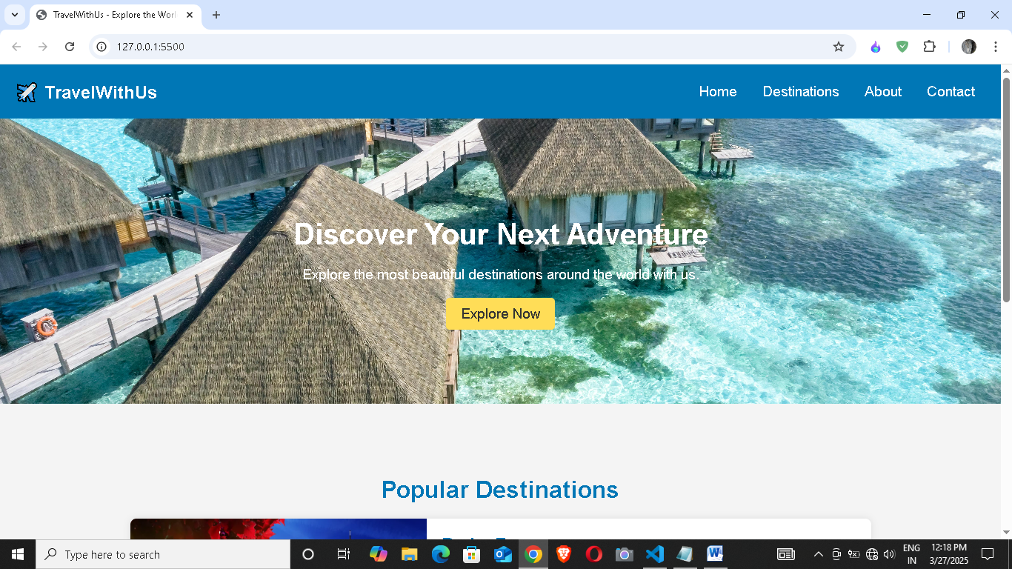

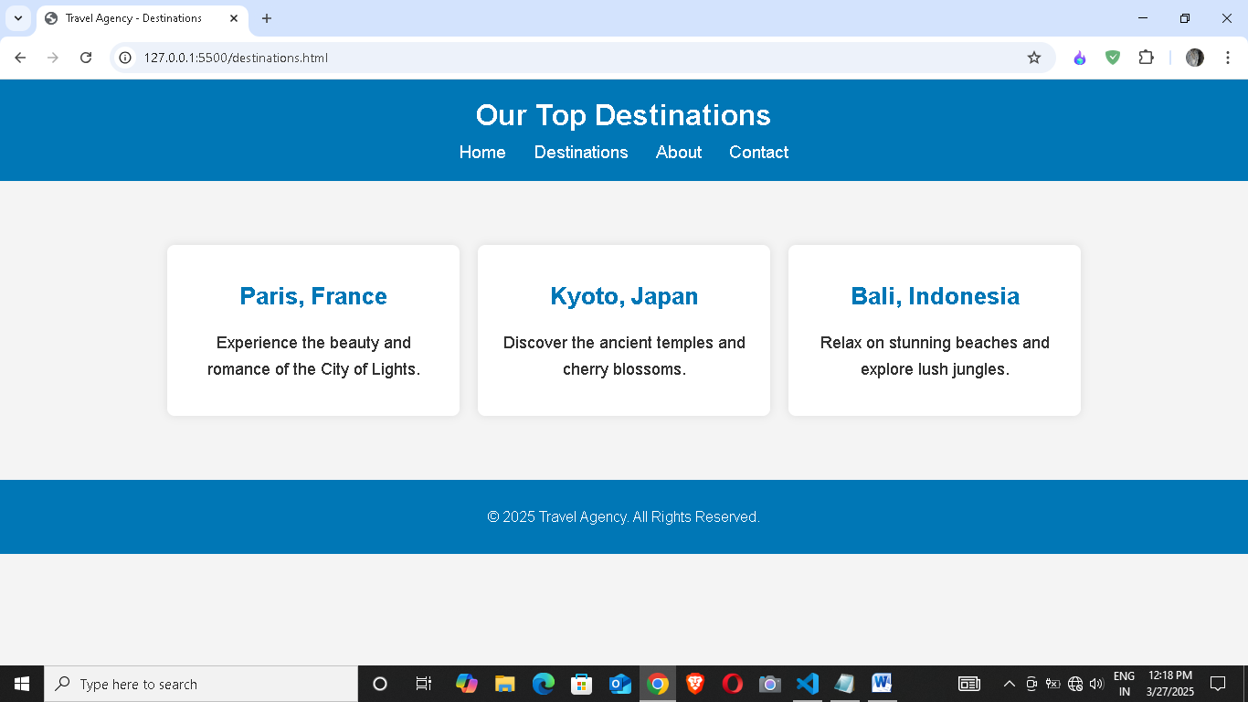

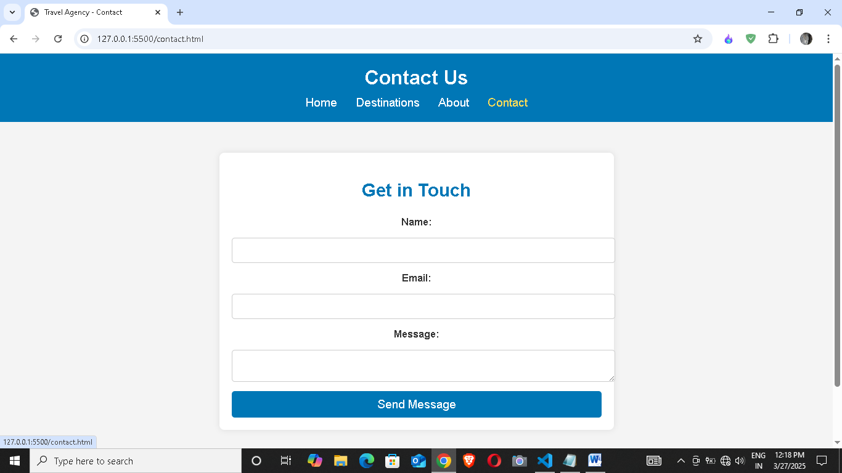

**BENEFITS OF THE PROJECT**

The travel agency website will provide several key benefits:

**1. Enhanced Online Presence**

* Establishes a professional digital identity for the travel agency.
* Increases visibility and credibility among potential customers.

**2. Improved Customer Engagement**

* Provides easy access to travel packages, destinations, and services.
* Encourages user interaction through appealing visuals and content.

**3. Increased Bookings & Sales**

* Attracts more clients by showcasing travel destinations effectively.
* Encourages inquiries and bookings through an intuitive contact system.

**4. Better Customer Support**

* Offers a dedicated contact page for customer queries.
* Provides essential travel information to guide potential travelers.

**5. Competitive Advantage**

* Keeps the agency ahead of competitors with a modern, well-structured website.
* Helps build trust and loyalty among customers.

**CONCLUSION**

A well-designed travel agency website is essential for attracting customers, providing valuable information, and ensuring a seamless booking experience. By incorporating a visually appealing design, user-friendly navigation, and engaging content, the website can inspire travelers and encourage them to explore various destinations. Additionally, integrating responsive design, secure booking systems, and interactive features enhances the user experience, making travel planning effortless and enjoyable. Ultimately, a professional and informative travel agency website serves as a gateway to unforgettable adventures, helping customers turn their travel dreams into reality.

FUTURE SCOPE OF THE PROJECT

The future scope of the travel agency website includes several potential enhancements to improve functionality, user experience, and business growth:

**1. Online Booking & Payment System**

* Implement an integrated booking system for travel packages.
* Enable secure online payments through credit/debit cards, PayPal, and other gateways.

**2. User Accounts & Profiles**

* Allow users to create accounts to save favorite destinations and track bookings.
* Provide personalized recommendations based on user preferences.

**3. AI-Powered Chatbot & Customer Support**

* Integrate a chatbot to assist users with inquiries 24/7.
* Provide instant responses and travel suggestions.

**4. Reviews & Testimonials Section**

* Enable customers to leave reviews about their travel experiences.
* Showcase positive testimonials to build trust and credibility.

**5. Multilingual & Currency Support**

* Add language options for international customers.
* Enable users to view prices in different currencies.

**6. Mobile App Integration**

* Develop a mobile app for better accessibility and convenience.
* Sync with the website for seamless booking and updates.

**7. Travel Blog & News Section**

* Publish travel tips, guides, and industry news.
* Improve SEO and engage visitors with valuable content.

BIBILIOGRAPHY/REFERENCES

WEBSITES

<https://www.w3schools.com/>

<https://www.javatpoint.com/>

<https://www.geeksforgeeks.com/>

<https://www.google.com/>

BOOKS

**HTML AND CSS: Design and build websites**

**Author: Jon Duckett**